Networking Basics
What is a Web Server?
How a Web Server Works
HTTP Basics (Req methods,headers,status codes)
Traditional V/s SPA
Serve static content
Reverse proxy
Load balancing
Key Features of Web Servers
Security Concepts(HTTPS,CORS,Firewall & WAF)
What is DNS?
How DNS Works
Types of DNS Records
Key DNS Concepts
DNS in Web Servers & Node.js Deployment
Common DNS Tasks

Web Server -- Is a combination of hardware & software.
Hardware – Desktop/Laptop/Server (Processor, RAM, HardDisk/SSD, I/O ports)
General purpose OS (Operating System)

Client – Server Architecture.
Web Browser/ POSTMAN/ CURL
Web Client – Uses Http/Https (Hyper Text Transfer Protocol (secured))
Hi – kd76hfkoiwe##959%20 (encryption) [client side] Some algorithms
kd76hfkoiwe##959%20 Hi (decryption) [Server side] (same algorithms)

Hotel (server)
- Ask for menu (Documentation – user guide – What resources available in that particular place)
- Order starter/food
- Eat
- Pay bill
- Done

Web Based application Layers (MVC – Model, View, Controller)
- Front End (View/Presentation Layer) – End User
- Back End (Business Logic Layer/ Controller Layer)
- DB (Data Storing Layer/Model/Entities)

Client Sends Request (HttpRequest) - Header & Body (HttpMethod, Requested Resource Details)

URL – Uniform Resource Locator (google.com – https://www.google.com)
https - protocol
www – world wide web (internet)

Database
DB URL : jdbc:mysql/pgsql/mssql/oracle
Jdbc:mysql://localhost:3306/<db_name>
Username & password (credentials)

Sample Request Object (Web Client )
HttpMethod [GET/POST/PUT/DELETE]
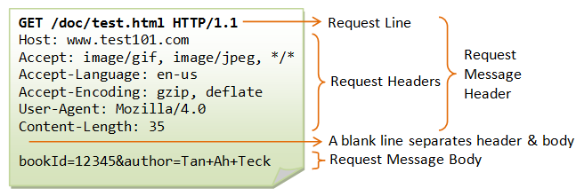

Sample Response Object
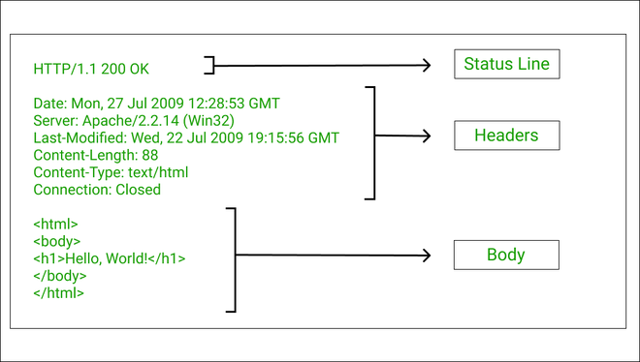

HttpStatus Code – 3 digit number
1xx – information
2xx – Success
3xx – Redirect
4xx – Client side errors
5xx – server side errors
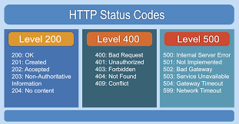
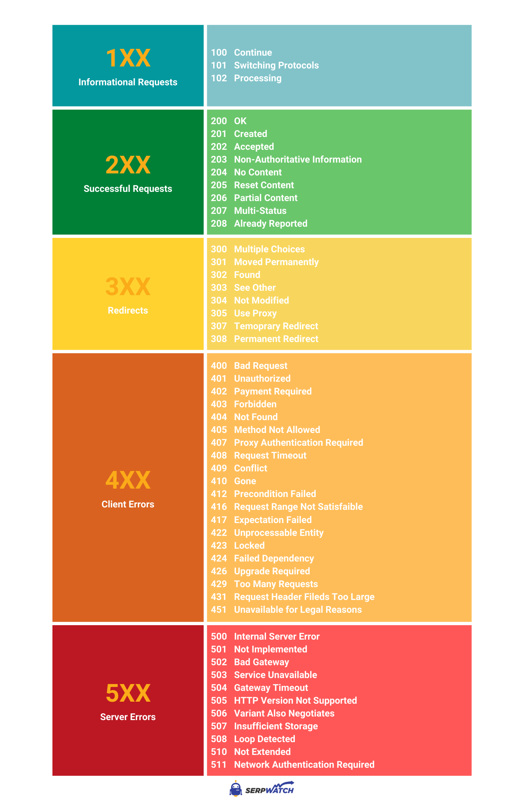
How Web Server Works
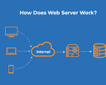
A web server works by listening for and responding to client requests, typically from a web browser. When a user enters a URL, their browser sends an HTTP request to the server's IP address (found via a DNS lookup). The server then processes the request, fetches the requested files (like HTML, CSS, and images), and sends them back as an HTTP response for the browser to render the page.

Client Google.com (domain Name) (dns lookup) DNS (domain name server)
Ipaddress – internet protocol address ipv4, ipv6
198.162.0.12
Web Server Static Response (HTML/CSS/JS) or Dynamic Response (Server side code – Python/PHP/ASP/JSP/JAVA/.Net… ) HTML/CSS/JS or JSON or XML format.

URI – Uniform Resource Identifier ( Web API) -- JSON/XML only (Universal Data Exchange format)

- Security
- Firewall /WAF
- SSL/TSL
- Certificate
- Load Balancing
- Reverse Proxy

Physical Machine / Virtual Machine. (Own house/ Rented or lease house)
- Processor
- RAM
- Storage
- Ports (i/o) Network ports [USB/HDMI/USB -C/ Ethernet]

Anti-virus Software & Update.

Firewall – (prevent loading some sites) -- Blacklisted Sites.
Proxy – (Forward Proxy & Reverse Proxy)
Http Methods, Http Status Code
MPA (Traditional Web Development) vs SPA
When I send the data from client to Server, 4 type of operations are expected.

4 Types of DB operation
CRUD – Create Read Update & Delete
DB operations type – READ (Wont change existing data), MODIFY (Modify existing content)
Sl No | HTTP METHOD | OPERATION | Input | Output
1 | POST | CREATE | Request Body without ID | Object with auto-generated ID
2 | GET | READ | No | All records
3 | PUT/PATCH | UPDATE | Primary_key in PathVariable, Updated Object in Request Body | Updated Object in DB
4 | DELETE | DELETE | Primary_key in Pathvariable | void

Two types of Read Operation
- Full Read – performance issues in prod env. (simple select query – mainly used in dev env only)
- Partial Read – select query with where condition (primary-key) --- ReadById, ReadByUniqueProp, limit.

PathVariable vs Request Parameter
https://gmail.com/inbox?email=abc@gmail.com&password=test123#
Sending a request to the gmail.com with two request parameters namely email & password with values “abc@gmail.com” and “test123#”

Request Parameters are Key, Value pairs. This will be appended at the end of URL.

http://docs.google.com/sheet/my-spread-sheet4 -- URI
We are a path variable whose data type is String. Path variable name might be Id or docId.

http://google.com/api/v2/employees/101 -- employeeId = 101 (data type is integer)

MPA or Tradition vs SPA
MPA – Multi – Page Application (website --- home.html/index.html, aboutus.html, contactus.html, services.html, payment.html -- multiple web pages) -- synchronous operations [Blocking Operation]
SPA – Single – Page Application ( Only one web Page [index.html] with multiple components) Asynchronous [Non-blocking operation] -- React/Angular/Vue –

Load Balancing --
Reverse Proxy – Sits between client & Server (Security, Load Balancing, Authentication & Autherization ) --

Caching – Redis (In-memory distributed cache)

Distributed (decentralized) vs Centralized. --
Data Centers – Availability Zones – Regions -

Continents – Countries -- State & Cities

Example Web Servers
- Apache Tomcat (open source)
- IIS
- Nginx (Serving millions of request at the same time – solves c10k problem )
Example Application Servers (JMS/JDNI/JPA etc.,)
- Weblogic /Dragonfly
- Web Sphere (IBM)
- GalssFish
Example Database Servers
- MySQL
- Postgres
- DB2
- MongoDB
- Redis
- Cassandra

SSL & TLS
SSL – Secured Socket Layer
TLS – Transport Layer Security

http – unsecured transmission
https – Certificate SSL (installation)

Modem – Modulation & Demodulation – Analog to Digital Conversion.
Analog Communication – Frequency (Hz) – Cycles/sec – AC – Alternating Current (50 Hz – 50 On/off --
WIFI Router – ISP
Processor Speed – i5/i7/i9 – Clock speed – 2.3GHz. 5GHz.

CORS – Cross Origin Resource Sharing (web server – in one place) (clients will be in another place)

Access-Control-allow-origin
CSRF – Cross Site Request Forgery
OWASP – Open Worldwide Application Security Project

DDoS – Distributed Deniel of Service Attack

https://owasp.org/Top10/2025/A01_2025-Broken_Access_Control/

firewall –
Types
- WAF (Web Application Firewall) – application layer security
- Host based Firewall
- Network based Firewall

WSL – Windows Subsystem for Linux (Linux kernel inside windows)

DNS – Domain Name Server
IpAddress – Numbers – Giving Name.
Process of Searching the IP-Address associated to Domain Name is called DNS lookup.

DNS Lookup Process
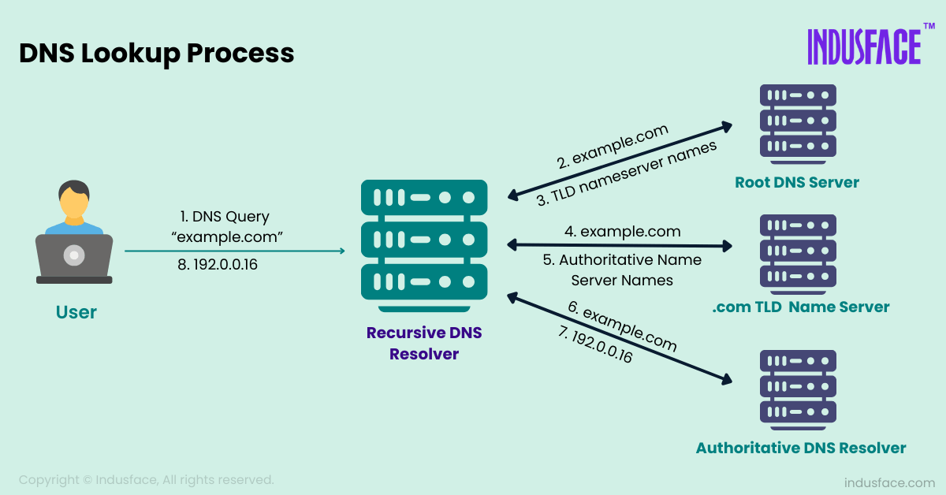

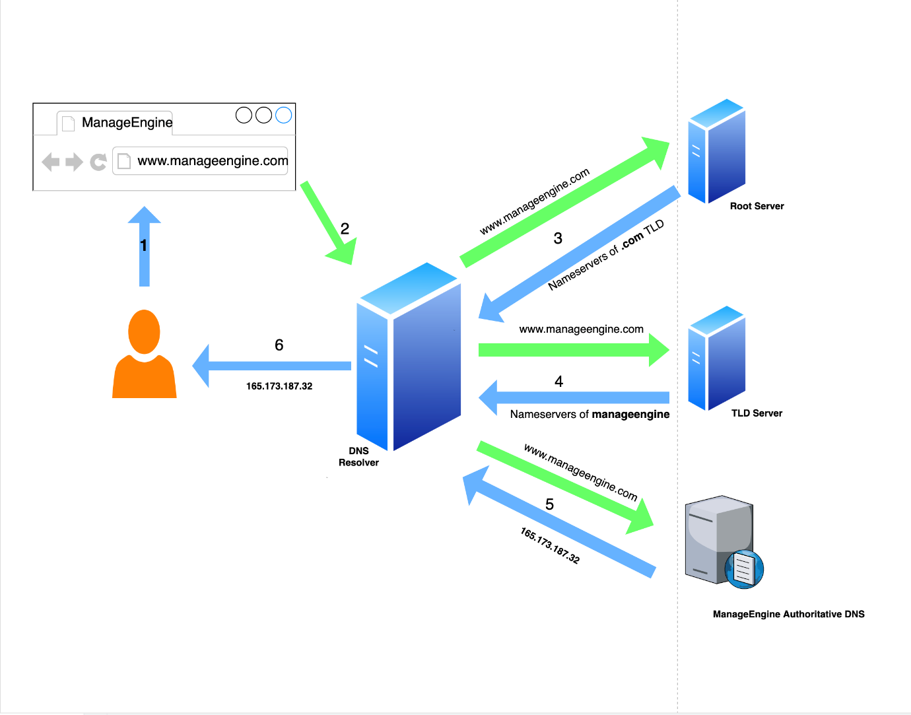

DNS Cache – Temp storage Area

RAM – Cache memories. It helps to store the data temporarily.
RAM – Read & Write Operations, Temp Memory, Volatile in nature.
RAM & ROM – Semi conductor memories. Costly. But very fast.
HDD/ CD/DVD – Optical or Magnetic memory. Cheap, but slow
ROM – Only Read Operation, Permanent Memory (BIOS, Boot info) Non-volatile.
Types of DNS
- Recursive DNS Resolver
- Root DNS Server
- TLD Name Server
- Authoritative DNS Resolver

TTL – Time To Live – Time in milliseconds 10minutes, 10hours, 1000 sec

HTML –
What , Why & How.
Parsing – Reading the actual data by ignoring the tags.
Rendering – Displaying the actual content in browser’s view port.

Parser is a Tool for Parsing Operation.

HTML – HyperText (Text with link to other doc or other location in the same document)
Markup – Tags for representing data schemantics/formatting
Language – Is a tool for communication.

- User Friendly
- Case & Space in-sensitive
- Easy to learn
- Can be created using any normal/plain text editor.
- HTML is the presentation/view layer.
- Browser will have 3 Engines (HTML Rendering Engine, CSS styling engine, JS engine)
- Web page = HTML (data) + CSS (styling/ beautification) +JS (interactivity)
- Elements, Attributes, Events
- DOM – Document Object Model
- Viewport – The area available for display the HTML document content (below title, address & bookmark bar)
- Responsive Design
- HTML Quiz in W3schools.com
- HTML Tags types (Basic, Formatting, Table, Form, Heading, Listing)
- Profile Page Sample.
- HTML form to get input from User. (Multiple field form)
- In-built HTML validation using maxlength, required, input type
- HTTP Request & HttpResponse
- Client & Server Concepts.
- Session & Local Storage.
- Web API, Geo Location Tags, Canvas & SVG -- Self learning
- Http Entities.

